**FakeNews**

**Team ID: B21-CAP0431**

**Selected theme: Economic Resilience  
Mentor: Subham Gupta** (mentoring done on 23 May 2021)

**Member : 1. M0020061 - Adrian Timotheus Salim**

**2. A2472345 - Rezi Rahdianor**

**3. A2472346 - Muhammad Rizal**

**4. C2242179 - Ahmad Farhan Putra Kusuma**

**5. M0020069 - Aditya Tresnobudi**

**6. C2242152 - Maliki Karim**

#### **Backgrounder:**

This application is an application that can detect news, whether the news is fake news or not, this application was created with the aim that people can better trust the information they read, because by doing these small things, it can have a big impact both for the economy and the economy. as well as public education.

Please specifically mention what you’ve done for each of the Learning Paths:

* Machine Learning: Building models with TensorFlow lite and tensorflow.js for detecting Fake News
* Android: Deployment of TensorFlow lite and creating both user and an admin app.
* Cloud: Provide resources and connect billing from firebase server to GCP to deploy tflite from machine learning.

#### 

#### **Screenshots**

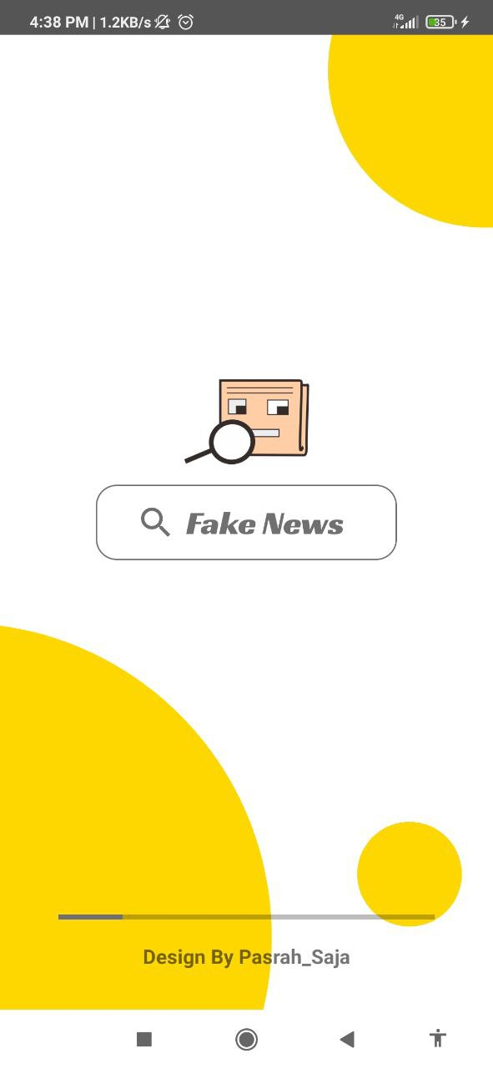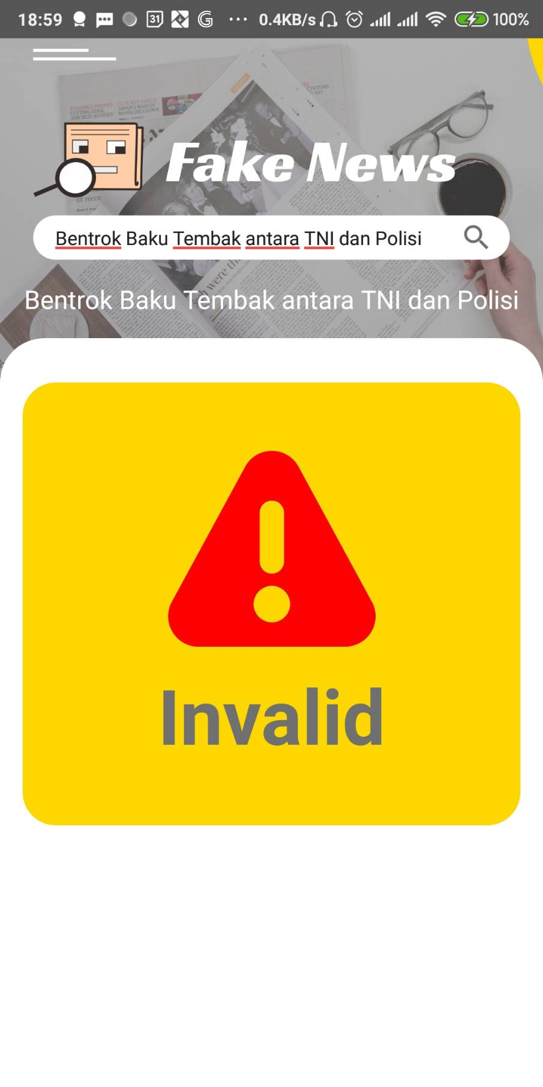

#### **Dataset Link**:

<https://www.kaggle.com/clmentbisaillon/fake-and-real-news-dataset>

#### **Deployed Link:**

<https://drive.google.com/file/d/1dukB2IR4midUddacjQirlRYzLy3eKg_1/view?usp=sharing>

#### **Github Repo Link:**

<https://github.com/rezir008/ProjectCapstoneFakeNews/>

#### **Academic Paper Link:**

[1] Manzoor, S. I., & Singla, J. (2019, April). Fake news detection using machine learning approaches: A systematic review. In 2019 3rd International Conference on Trends in Electronics and Informatics (ICOEI) (pp. 230-234). IEEE. <https://ieeexplore.ieee.org/abstract/document/8862770>

[2] Oshikawa, R., Qian, J., & Wang, W. Y. (2018). A survey on natural language processing for fake news detection. arXiv preprint arXiv:1811.00770. <https://arxiv.org/abs/1811.00770>

#### **10-Min Video Presentation Link:**

<https://youtu.be/N8YzZ5lbVOk>

#### **Slide Presentation Link:**

<https://drive.google.com/file/d/1KZkVVFnx4OJjEhx2ihu7XGGiW_Wxk12l/view?usp=sharing>